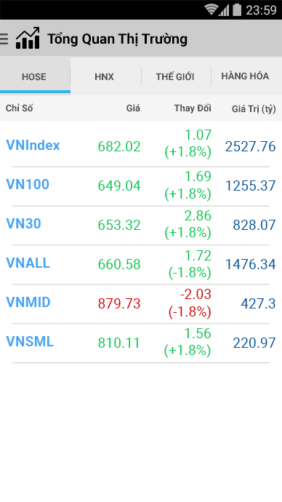

16

8

12

12

56

36

52

52

96

8

8

8

8

All in [Roboto](https://fonts.google.com/specimen/Roboto) font.

|  |  |
| --- | --- |
|  | Icon Stock: 32dp  Text Size: 20sp  Text Style: Bold  Text Color: #000000 |
|  | All in Capslock  Text Size: 14sp  Text Color: #505050 |
|  | Text Size: 14sp  Text Color: #505050  Align: center_vertical | left |
|  | Text Size: 14sp  Text Color: #505050  Align: center_vertical | right |
|  | Text Size: 18sp  Text Style: Bold  Text Color: #42A5F5  Align: center_vertical | left |
|  | Text Size: 18sp  Text Color: #00C853  Align: center_vertical | right |
|  | Text Size: 18sp  Text Color: #01579B  Align: center_vertical | right |
| Divider | Height: 1dp  Line Color: #CCCCCC |